create database library;

USE library;

CREATE TABLE books(

id INT PRIMARY KEY AUTO_INCREMENT,

title VARCHAR(255),

author VARCHAR(100),

year YEAR,

genre VARCHAR(100));

select * from books;

drop table books;

INSERT INTO books(title, author, year, genre)

VALUES("The Great Gatsby", "F. Scott Fitzgerald", 1925, "Fiction"),

("Pride and Prejudice", "Jane Austen", 1913, "Romance"),

("To Kill a Mockingbird", "Harper Lee", 1960, "Fiction"),

("1984", "George Orwell", 1949, "Dystopian"),

("Moby Dick", "Herman Melville", 1951, "Adventure");

# Write a query to select all books where the title starts with the letter 'T' using the LIKE operator.

SELECT * FROM books WHERE title LIKE 'T%';

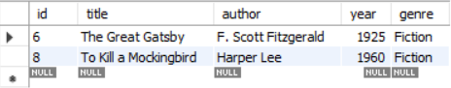

# Write a query to find all books where the author's last name ends with 'son' using the LIKE operator.

SELECT * FROM books WHERE author LIKE '%son';



# Write a query to find all books where the title contains the word 'and' using the LIKE operator.

SELECT * FROM books WHERE title LIKE '%and%';

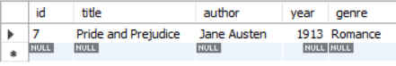

# Write a query to retrieve all books where the title ends with the word 'bird' using the LIKE operator.

SELECT * FROM books WHERE title LIKE '%bird';

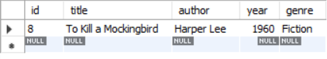

# Write a query to find all books where the title has exactly 3 characters using the REGEXP operator.

SELECT * FROM books WHERE title REGEXP '^[A-Za-z0-9]{3}$';



# Write a query to select all books where the title contains a number using the REGEXP operator.

SELECT * FROM books WHERE title REGEXP '[0-9]';

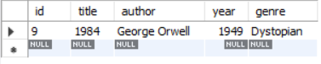

# Write a query to retrieve all books where the author's name starts with any letter between 'A' and 'J' using the REGEXP operator.

SELECT * FROM books WHERE author REGEXP '^[A-Ja-j]';

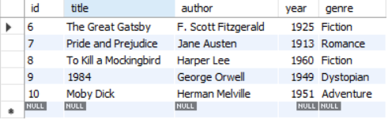

# Write a query to select all books where the genre is either 'Fiction' or 'Adventure' using the REGEXP operator.

SELECT * FROM books WHERE genre REGEXP '^(Fiction|Adventure)$';

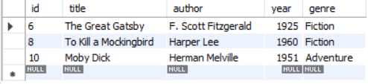

# Write a query to find all books where the title contains at least one uppercase letter using the REGEXP operator.

SELECT * FROM books WHERE title REGEXP '[A-Z]';

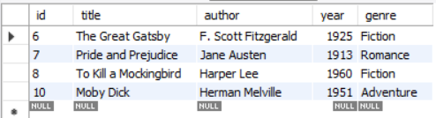

# Write a query to find all books where the year of publication is between 1800 and 1950 using the LIKE operator.

SELECT * FROM books WHERE year BETWEEN 1800 AND 1950;

SELECT * FROM books WHERE year LIKE '18%' OR year LIKE '19%' AND year < '1951';

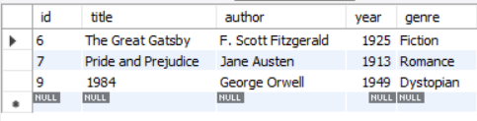

# Write a query to retrieve all books where the author's name contains exactly two words using the REGEXP operator.

SELECT * FROM books WHERE author REGEXP '^[A-Za-z]+ [A-Za-z]+$';

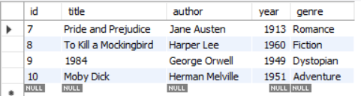

# Write a query to find all books where the title starts with the letter 'P' and contains exactly two words using the REGEXP operator.

SELECT * FROM books WHERE title REGEXP '^P [A-Za-z]+$';

SELECT * FROM books WHERE title REGEXP '^P[A-Za-z] * [A-Za-z]+$';

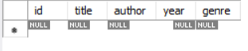

# Write a query to find all books where the title contains any special characters (e.g., '!', '@', '#', etc.) using the REGEXP operator.

SELECT * FROM books WHERE title REGEXP '[^A-Za-z0-9 ]';

